**SCALA PROGRAMMING**

DATE: 07 SEPTEMBER 2023

FINDING THE GREATEST NUMBER BETWEEN 2 NUMBERS:

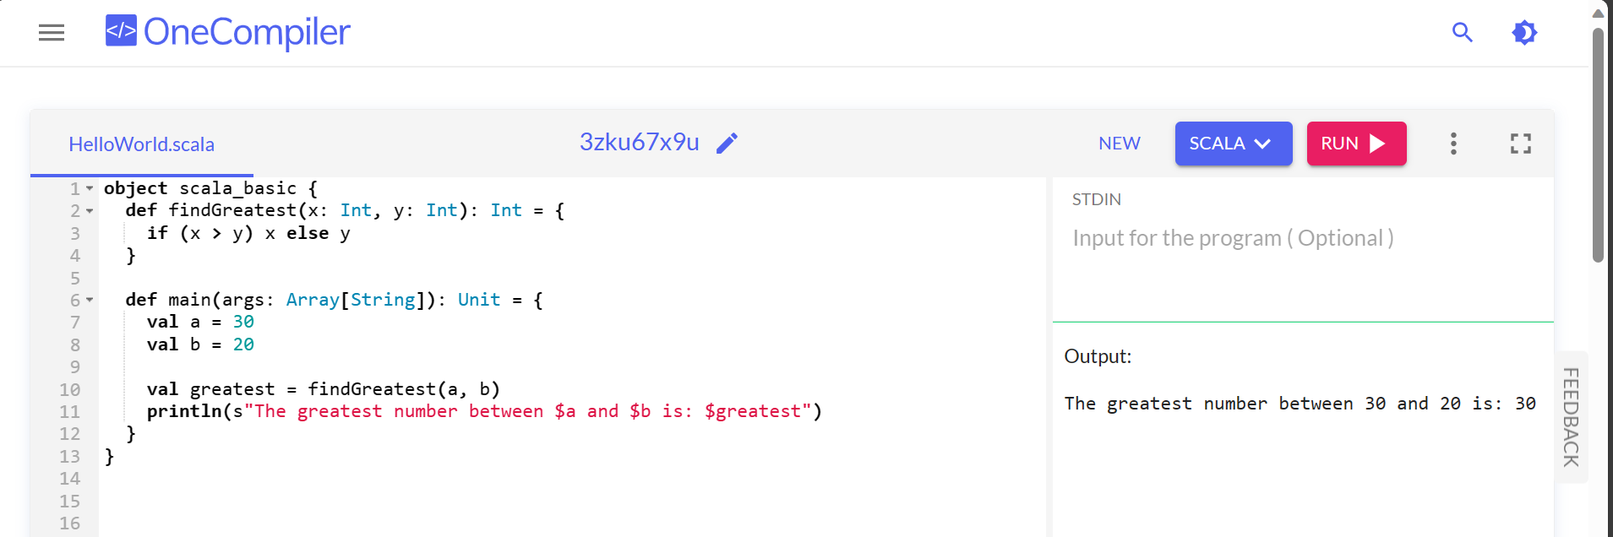

IF CONDITION WITH NUMBERS:

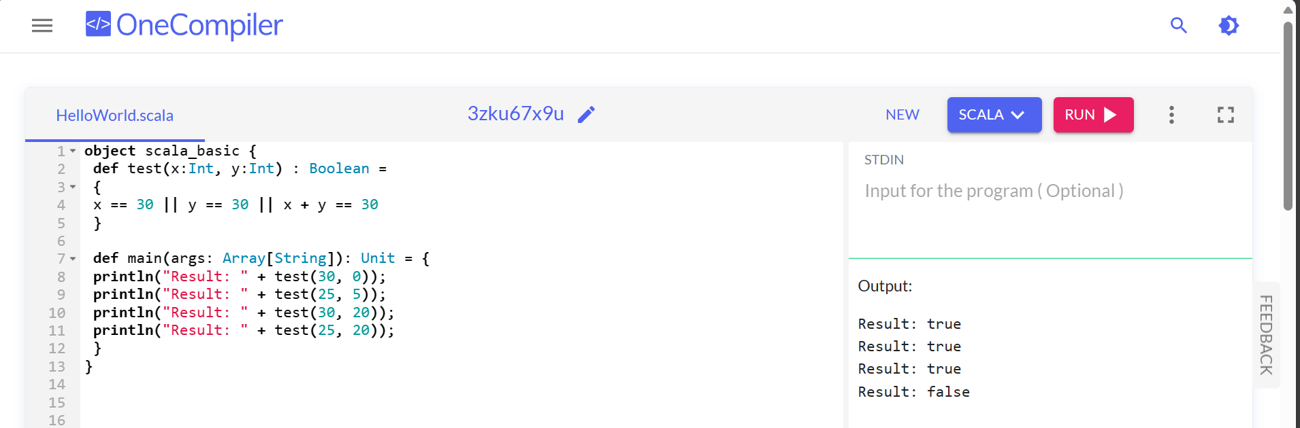

To check a given integer and return true if it is within 20 of 100 or 300:

